Name: Khadija Parvaiz Butt

Roll Number: MCSF19M001

Subject: Mobile Computing

**Github Account:**

* First go to github website.
* Now Create a new account

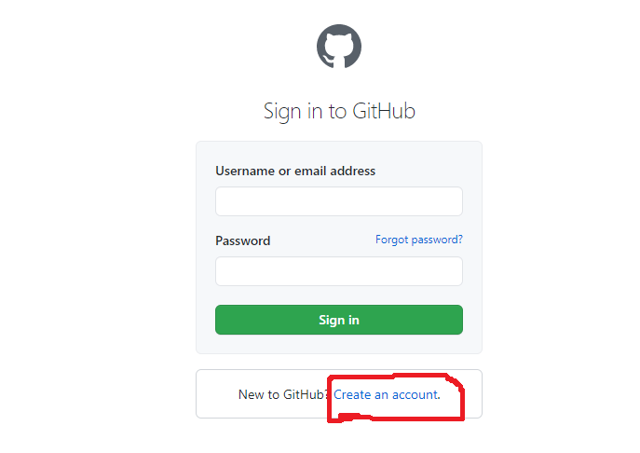

**Create Central Repository:**

Create the central Repository.

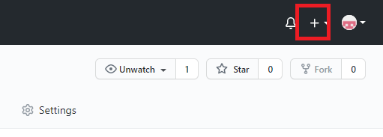

Give a Unique Name to your repository.

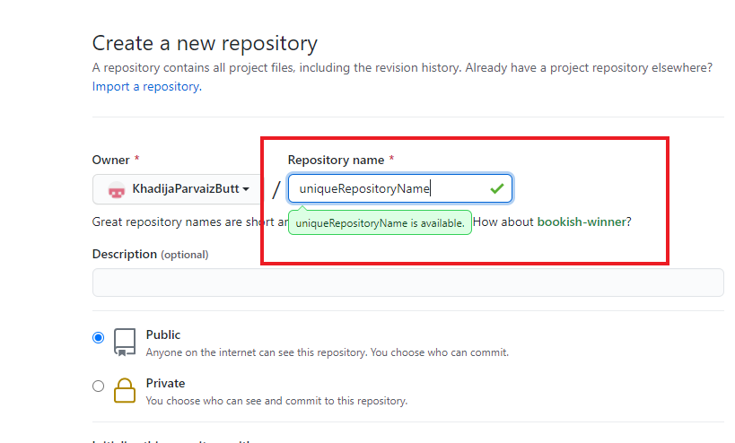

Then a URL will be given to your unique repository.

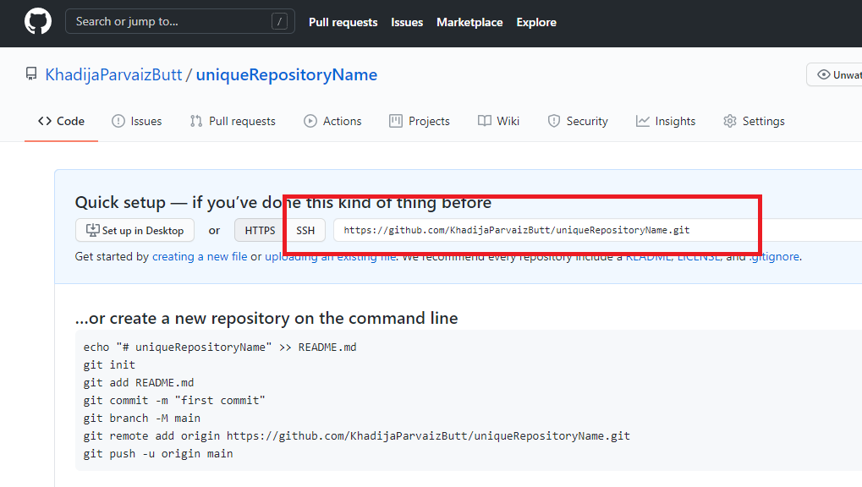

**Create Clone:**

git clone URLOfRepository

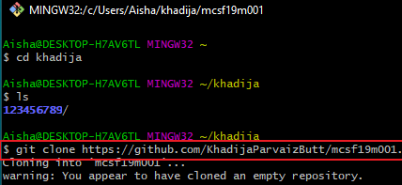

Add File/Folder: